US Trains Mexico Officials to Carry Out Oral Trials
Written by Elyssa Pachico|Insightcrime.org
Monday, 13 February 2012
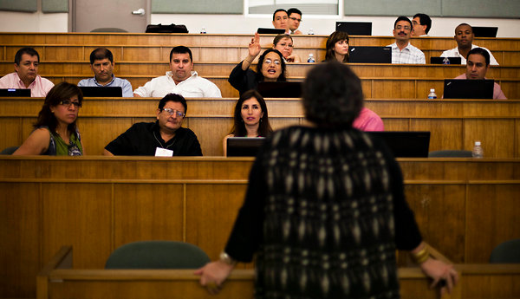
The US Justice Department will train thousands of Mexican public servants to carry out oral trials, as Mexico rushes to implement a series of sweeping judicial reforms in time for a 2016 deadline.

Up to 8,000 agents from Mexico's Ministry of Public Security, the Federal Police and the Attorney General's Office will be trained to hold oral, public trials. The initiative will be funded under the terms of the US's primary security program for Mexico, the Merida Initiative.

According to a press release from Mexico's Attorney General's Office, the training program, known as the "Diamond Project," will help attorneys and police make the move to Mexico's new accusatorial trial system. This includes training in prosecutorial skills, like delivering opening statements, cross-examination, and using police detectives as witnesses. The public servants will also be trained in investigative techniques, such as how to conduct searches and record evidence, in order to build better cases against suspected criminals.

Mexico introduced oral trial proceedings in a series of reforms in 2008. This was a dramatic shift from the old model, in which trials were conducted mainly through paperwork, the accused were presumed guilty rather than innocent, and a defendant could be convicted without ever seeing a judge. The reforms also expanded the rights of the accused, putting new emphasis on following due process.

Under law, the reforms must be implemented nationwide by 2016. But so far, less than a quarter of Mexico's 32 states have begun putting them into place.

Mexico's traditional inquisitorial system was slow and inefficient. According to statistics released by Mexico's Attorney General Office, only 28 percent of federal arrests in 2010 resulted in a trial. Over 106,000 detained people went free, mostly because authorities lacked the evidence to move the case forward. A report released by Human Rights Watch in November 2011 found that federal judges had secured just 22 convictions for offenses tied to organized crime since 2007.

The "Diamond Project" aims to speed up the pace of judicial reform with US assistance. Prior to 2011, the Merida Initative, a $1.5 billion plan that delivers US aid to Mexico with the purpose of fighting drug trafficking, focused principally on military aid. But last year, US State Department officials announced they would shift the focus towards improving Mexico's judicial institutions.

Alongside this new focus, the US halved the amount of aid allocated to Mexico, proposing a budget of $282 million for the 2012 fiscal year, down from the $582 million allocated in 2010. At the time, the US Embassy in Mexico said the drop in aid reflected the new priority on strengthening Mexico's institutions, not delivering military equipment and technical assistance.

The training offered under the "Diamond Project" is the clearest sign yet that the US intends to stand by its commitment. The US would do well to focus on three issues. The first is speeding up the time it takes to settle cases, without sacrificing the need for due process. If the system was seen as more effective, this would help it gain legitimacy with the public.

The second is confronting the use of forced confessions as evidence. According to a 2011 report by the University of San Diego's Trans-Border Institute, judges in seven states said in a survey that coercion was "always" used to force confessions.

The third issue is ensuring that cases related to organized crime are tried with respect for human rights and due process. At the moment, prosecutors can hold suspects suspected of links to organized crime for 80 days without charge. This is in contrast to individuals charged with other types of crime, in which prosecutors must build cases before making an arrest, unless the suspect is caught in the act.

The Diamond Project may be the most concentrated effort yet, at least from the US side, to address structural reforms in Mexico's greatly troubled judiciary. But the example of Colombia, where the US Justice Department provided $114 million between 2000 and 2007 to help improve the rule of law, is a reminder that change will be slow. Colombia made the transition from a written trial system to an accusatory one between 2004 and 2008. Even with the transition completed, there has been little improvement to the overall conviction rate. While cases involving those caught in the act are now processed more quickly, the impunity rate for murder is still at 71 percent in Colombian capital Bogota.

