Sacred Cows No More

Enrique Peña Nieto’s proposal to reform television and telecoms shows he is serious about shaking up the economy
Mar 16th 2013 | MEXICO CITY |The Economist
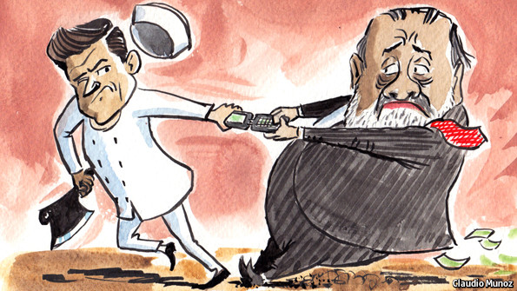
DURING Enrique Peña Nieto’s successful run for Mexico’s presidency last year, political observers took his promises of structural reform with a large pinch of salt. Mr Peña belongs to the Institutional Revolutionary Party (PRI), which ruled the country autocratically for seven decades and had blocked or watered down most of the legislative agenda of Felipe Calderón, the president in 2006-12. Moreover, he owed much of his rise to prominence to Televisa, a television network that has 70% of Mexico’s national free-to-air market. The company broadcast soap operas starring his future wife and gave him fawning coverage in the campaign. The common view held that Mr Peña would impose no more than cosmetic reforms on Televisa—or on any of the other interest groups that have hamstrung Mexico’s economy.
In the space of just two weeks, however, Mr Peña has revealed the extent of his ambition. Now that the PRI has retaken the presidency, he seems intent on clearing out the monopolistic blockages to Mexico’s growth and confronting some of its most formidable lobbies. On February 26th prosecutors arrested Elba Esther Gordillo, the head of the teachers’ union, on embezzlement charges. And on March 11th Mr Peña turned on Televisa itself—as well as Carlos Slim, the world’s richest man—by announcing a reform that could at last open up some of Mexico’s least competitive industries. “I’m here to transform the country, not simply run it,” the president said the day before the plan was unveiled.
Mr Slim, who controls the telecoms empire América Móvil, and Emilio Azcárraga, the boss of Televisa, are Mexico’s best-known oligarchs. Their companies both enjoy the lion’s share of their markets. In 2012 the OECD estimated that the dearth of competition in telecoms cost the country’s economy $25 billion a year, because of high prices for broadband and calls from fixed lines to mobile phones. Regulators have tried to chip away at Mr Slim’s empire for years. But its lawyers have frequently obtained injunctions to prevent inconvenient rulings from taking effect.
Mr Peña’s proposal, which his finance minister says would increase Mexico’s annual economic growth rate by one percentage point, would leave América Móvil with little wiggle room. He intends to set up a new, autonomous telecoms institute with the power to impose stiff penalties on firms that control over half their markets, or even break them up. Assuming a separate regulatory reform bill is also passed, the agency’s decisions would take effect immediately and remain in force unless reversed by a court judgment.
Moreover, the institute could implement asymmetric connection fees. That would force América Móvil to pay more to route calls to its competitors than vice versa. The plan would also scrap foreign-ownership limits and set up a state-owned “carrier of carriers”. Investors seem to believe the plan will have an impact: América Móvil’s shares fell by 9% in the three days after it was revealed.
In television, the reform seeks to bring new competitors into the market. It would create two new national networks by holding spectrum auctions in which Televisa and its smaller rival, TV Azteca, would not take part (though Mr Slim, who is eager to enter the broadcast business, presumably could). Non-Mexicans could hold up to 49% of broadcasters. Finally, it would force content providers to offer their shows to all cable-TV firms, and cable-TV firms to carry the shows of all content providers.
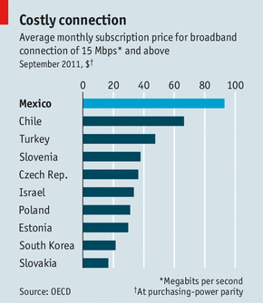
The plan would require a constitutional amendment to change foreign-ownership limits. That entails support from two-thirds of Congress and a majority of state legislatures. When the PRI was in opposition, it made sure that Mr Calderón—who often listed antitrust reform as a main objective—fell short of those thresholds. But Mr Calderón’s conservative National Action Party and the centre-left Party of the Democratic Revolution have been more accommodating: they have both signed a deal with Mr Peña to support a joint policy agenda. That will make it harder for the incumbent firms to block the plan. If the president does get his way, he might build enough confidence to push through promised energy and fiscal reforms as well.
Mr Peña’s proposal is good news in economic terms. For the opposition, however, it is potentially double-edged. After generations of hegemonic rule, the centrist PRI is still the country’s strongest party. If Mr Peña succeeds, it will be able to argue that it is the only lot that can get anything done. Mexican consumers may see more competition under Mr Peña. The opposition will have to work hard to ensure that Mexican voters do not see less.

