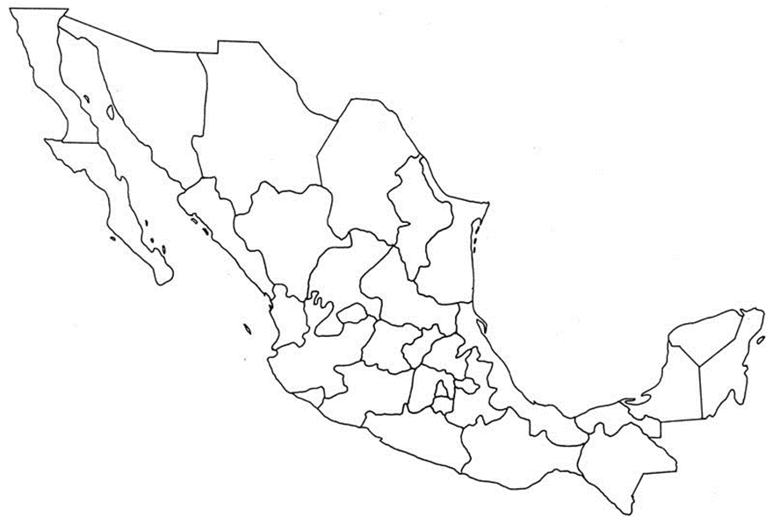

1. 11. 21.

2. 12. 22.

3. 13. 23.

4. 14. 24.

5. 15. 25.

6. 16. 26.

7. 17. 27.

8. 18. 28.

9. 19. 29.

10. 20. 30.

31.

Identify all 31 Mexican states by number:

Label these physical features on the map: Gulf of Mexico, Caribbean Sea, Rio Grande, Sierra Madre Oriental Mountains, Sierra Madres Occidental Mountains, Yucatan Peninsula, Pacific Ocean

Label these cities: Mexico City, Acapulco, Cancun, Hermosillo, Guadalajara, Monterey, LaPaz, Chihuahua, Colma