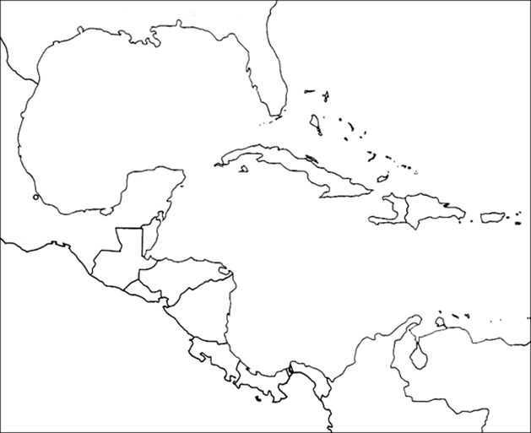

Belize Gulf of Mexico

Guatemala Pacific Ocean

Honduras Atlantic Ocean

Cuba Caribbean Sea

Panama The Bahamas

El Salvador

Nicaragua

Costa Rica

Dominican Republic

Haiti

Puerto Rico

Colombia