Map of Nigeria and Region
Directions: Draw/Label the following parts of the maps below – Abuja, Lagos, Port Harcourt, Sokoto, Kano, Yola, Enugu, Niger River, Benue River, Niger Delta, Atlantic Ocean, Gulf of Guinea, Mandra Mountains, Shebshi Mtns., Jos Plateau, Lake Chad, Niger, Chad, Cameroon, Benin, Burkina, Togo, Central African Republic, Ghana, Gabon, Equatorial Guinea, Ethnic Areas: Hausa & Fulani, Yoruba and Igbo.
Map of Nigeria
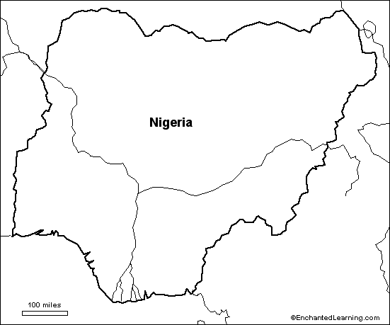

Map of Africa
