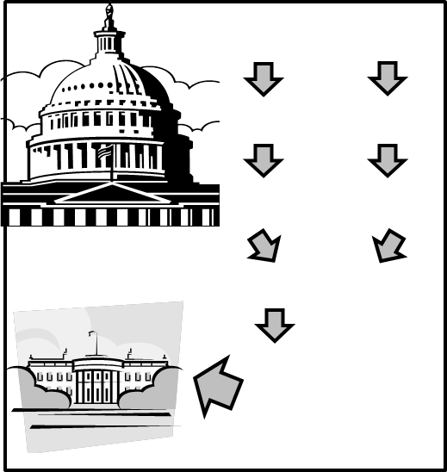
Step #1

Step #2

Step #3
Step #6
Step #4

Step #5

A. The bill is referred to appropriate committee where it is debated, marked-up and voted on either favorably or unfavorably. If it is voted on unfavorably it is said to have “died.”
B. The bill must go through all previous steps in the opposite house of Congress.
C. The bill must be introduced on the floor of either the House or the Senate. At this point, it is officially given a number.
D. If the bill has passed both houses of Congress, the bill goes to a conference committee.
E. The President may choose to sign the bill into law, veto it, or not sign the bill.
F. The bill is debated on the floor of the house that it was introduced in. There are different rules for debate, but once debate has ended, the bill is voted on a first time. If it passes, it moves on to the next step.

