***Constitution USA: A More Perfect Union***  Name: ______________________________________________

In this episode, you will explore the delicate balance of federalism. Use this guide to help you pull key ideas from the video and help you build your understanding of, our “road map” to, the Constitution in your life.

1. What are the two main components of federalism in our system?
2. The Harborside Company in California can be seen as a respected business. In what realm is Harborside an unlawful business? How are the state and federal laws at odds?
3. List some characteristics of our national government before and after the Constitution:



1. What was the real reason for the states to unite?
2. In which city did the framers of the Constitution meet in 1787?
3. Who is the guy who had a plan for a new government? (Hint: He is known as the “Father of the Constitution”)
4. What were some of the issues the delegates faced with creating a strong central government?
5. How did the delegates resolve the issue of representation?
6. Explain the Commerce Clause.
7. Explain the Supremacy Clause.
8. Why do we give power to the states at all? What is Gary’s reasoning behind state power? Do you agree with him?
9. What is meant by the term “laboratories for democracy?” List two examples of good ideas that came from states.
10. Why did the federal government build the Hoover Dam? How did building the Hoover Dam support the posterity of the Union?
11. Why do some people think the New Deal had negative outcomes?
12. What was the name of the court case that ended segregation in schools? Name the branch of government that ruled that segregation was illegal. How did the state governments push back?
13. Imagine you are hearing the case of Wickard v. Filburn. What is your opinion on the case? What is your argument and why?
14. What is your opinion on the issues below—who should have the final word, the state governments or the federal government? **Explain one of your choices**.

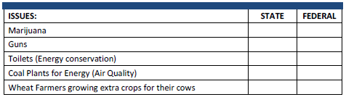

1. Have we struck the proper balance between the federal government protecting our rights and making laws effectively, or has the government overstepped its bounds? **Explain.**