USE YOUR NOTES TO FIND ANSWERS | HOUSE | SENATE
How many members?

How long is their term?

The number of representatives per state is based on what?

Minimum Age Requirement

Minimum time one must be a citizen of the US
Residency Requirement

Term Limits?
YES OR NO

- How many representatives does Illinois currently have?

- Name our U.S. Representative from the 14th District in which we live

- Name our two U.S. Senators from Illinois.

- What are the five jobs of any Congressman?

- Which way do you feel your Congressmen should represent your interests? (delegate, trustee, partisan or politico). Explain your answer.

Committees in Congress p 329-333
Type of Committee | Purpose/Definiton
Standing Committee

Joint Committee

Select Committee

Conference Committee

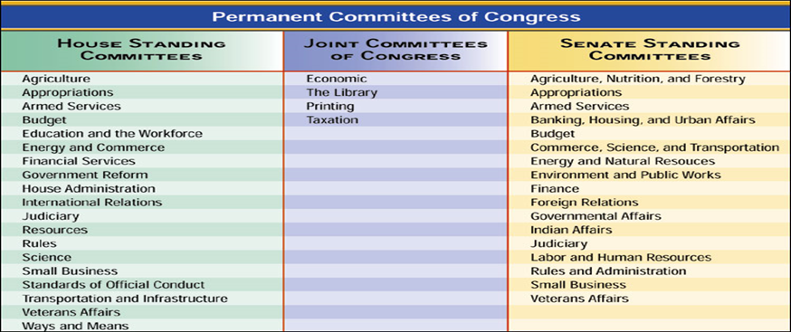
Use the chart above to name the committee in Congress in which the following bills would be referred to.
SB #33
Great Lakes Ecosystem Protection Act
HB # 797
Increase the Federal Minimum Wage
HB #442
Rebuild Bridges in America to Modern Code
SB #2671
PTSD and Mental Health Awareness for Iraq War Veterans

Define the following terms from Chapter 12
Speaker of the House rider

President of the Senate filibuster

President Pro Tempore cloture

Majority/Minority Leader seniority rule

Majority /Minority Whip party caucus

