China Map Directions: On the map below draw/label the following:
Gobi Desert Beijing India Russia Indonesia
Yangtze River Shanghai Sri Lanka Philippines Malaysia
Himalayan Mountains Hong Kong Nepal Vietnam China
Huang He/Yellow River Xinjiang North Korea Laos Bhutan
Tibet Guangzhou South Korea Cambodia Manchuria
Pearl River Chongqing Japan Myanmar (Burma) Bangladesh
South China Sea Tianjin East China Sea Bay of Bengal Thailand
Sea of Japan Macau Taiwan Mongolia Luzon Strait
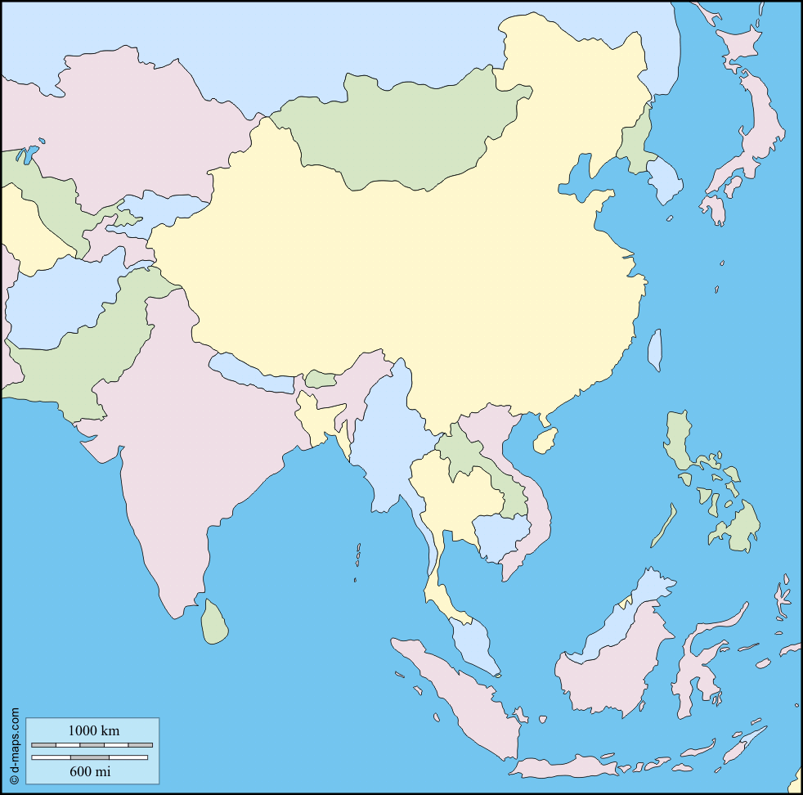
Yellow Sea

