Señores, Start Your Engines

Cheaper than China and with credit and oil about to start flowing, Mexico is becoming a Brazil-beater
Nov 24th 2012 |From The Economist
CUERNAVACA, A ONCE pretty, now sprawling city with volcano views just south of the capital, is a typical Mexican town. Hernán Cortés stopped off there after toppling the Aztec emperor Moctezuma in 1520; the conquistador’s stables have since been converted into a smart hotel. Yet on the outskirts of the city, in an enormous industrial park, a visitor could forget he was in Latin America. Nissan, a Japanese car giant, has created a factory the size of a village where from next year it will begin turning out thousands of yellow and chessboard-chequered New York City taxis.
Once shuttered off by tariffs and trade controls, Mexico has opened up to become a place where the world does business. The North American Free-Trade Agreement (NAFTA), which in 1994 eliminated most tariffs between Mexico, the United States and Canada, was only the beginning: Mexico now boasts free-trade deals with 44 countries, more than any other nation. In northern and central Mexico German companies turn out electrical components for Europe, Canadian firms assemble aircraft parts and factory after factory makes televisions, fridge-freezers and much else. Each year Mexico exports manufactured goods to about the same value as the rest of Latin America put together. Trade makes up a bigger chunk of its GDP than of any other large country’s.
Normally that would be a good thing, but after the 2007-08 financial crisis it meant that Mexico got a terrible walloping. Thanks to its wide-open economy and high exposure to the United States it suffered the steepest recession on the American mainland: in 2009 its economy shrank by 6%. The country had already had a rocky decade. When China joined the World Trade Organisation in 2001, it started undercutting Mexico’s export industry. In the ten years to 2010 Mexico’s economy grew by an average of just 1.6% a year, less than half the rate of Brazil, which flourished in part by exporting commodities to China.
But now changes are under way, in Mexico’s factories, its financial sector and even its oil and gas fields, that augur well for a very different decade. Latin America’s perennial underachiever grew faster than Brazil last year and will repeat the trick this year, with a rate of about 4% against less than 2% in Brazil. Mr Peña is aiming to get annual growth up to 6% before his six-year presidency is over. By the end of this decade Mexico will probably be among the world’s ten biggest economies; a few bullish forecasters think it might even become the largest in Latin America. How did Mexico achieve such a turnround?
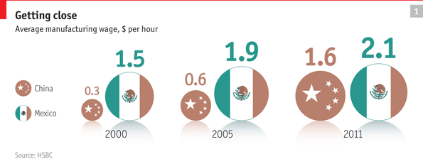
China’s cut-price export machine sucked billions of dollars of business out of Mexico. But now Asian wages and transport costs are rising and companies are going west. “The China factor is changing big-time,” says Jim O’Neill, the Goldman Sachs economist who in 2001 coined the “BRICs” acronym—Brazil, Russia, India and China—much to Mexico’s irritation. China is no longer as cheap as it used to be. According to HSBC, a bank, in 2000 it cost just $0.32 an hour to employ a Chinese manufacturing worker, against $1.51 for a Mexican one. By last year Chinese wages had quintupled to $1.63, whereas Mexican ones had risen only to $2.10 (see chart 1). The minimum wage in Shanghai and Qingdao is now higher than in Mexico City and Monterrey, not least because of the rocketing renminbi.
Right next door
Hauling goods from Asia to America is costlier too. The price of oil has trebled since the start of the century, making it more attractive to manufacture close to markets. A container can take three months to travel from China to the United States, whereas products trucked in from Mexico can take just a couple of days. AlixPartners, a consultancy, said last year that the joint effect of pay, logistics and currency fluctuations had made Mexico the world’s cheapest place to manufacture goods destined for the United States, undercutting China as well as countries such as India and Vietnam.
Companies have noticed. “When you wipe away the PR and look at the real numbers, Mexico is startlingly good,” says Louise Goeser, the regional head of Siemens, a German multinational. Siemens employs 6,000 people at 13 factories and three research centres around Mexico. From its recently enlarged facility in Querétaro, in central Mexico, surge-arrestors and transformers trundle up to warehouses in the central United States in two days. Ms Goeser says that Mexican workers are well qualified as well as cheap: more engineers graduate in Mexico each year than in Germany, she points out.
In Aguascalientes, not far away, Nissan is building a $2 billion factory. Together with an existing facility it will turn out a car nearly every 30 seconds. About 80% of the parts in each car are made in Mexico. By using local suppliers, the company is “armoured” against currency fluctuations, says José Luis Valls, head of Nissan Mexico. “If you are localised, you can navigate through floods and storms. If you depend on imports of components, you are very fragile.” In nearby Guanajuato Mazda and Honda are building factories; Audi is constructing a $1.3 billion plant in Puebla. This year Mexico will turn out roughly 3m vehicles, making it the world’s fourth-biggest auto exporter. When the new factories are up and running, capacity will be 4m.
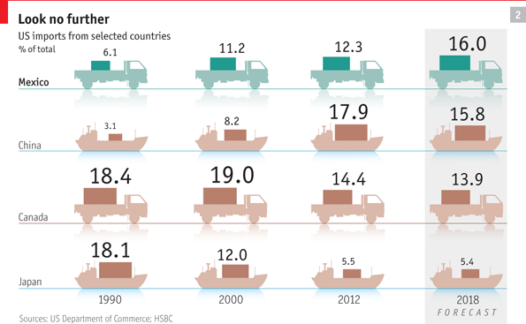
According to projections by HSBC, in six years’ time the United States will be more dependent on imports from Mexico than from any other country (see chart 2). Soon “Hecho en México” will become more familiar to Americans than “Made in China”.
On the opposite side of Cuernavaca from Nissan’s gigantic factory, Antonio Sánchez plays a smaller role in Mexico’s motor business. At his carwash customers queue to pay 46 pesos ($3.60) for their cars to gleam in the ever-present sun. Mr Sánchez seems to have enough business to open another branch, but credit is scarce and expensive. He explains that banks tend to charge interest rates of 25% or more and demand collateral worth three times the value of the loan. “It’s complicated, expensive and the risk is too much,” he says.
Mexican businesses have been fighting with one hand tied behind their backs, thanks to a chronic credit drought. Lending is equivalent to 26% of GDP, compared with 61% in Brazil and 71% in Chile. The drought started with the “tequila crisis” of 1994, when a currency devaluation triggered the collapse of the country’s loosely regulated banking system. Banks spent the best part of a decade dealing with their dodgy legacy assets and were nervous about making new loans.
But things are looking up. Inflation, now running at 4.6%, has been well under control for ten years. The conservatively run Mexican subsidiaries of foreign banks such as BBVA, Citigroup and Santander are all rated higher than their American or European parent companies. Now they are starting to turn on the credit tap. Loans to companies are growing at 12% a year and to individuals at 23%. Given that many enterprises are informal, many of these “personal” loans probably go to businesses, according to David Olivares of Moody’s, a ratings agency. “There are many financing opportunities in Mexico that are not tapped,” says Agustín Carstens, the governor of the central bank. This gives Mexico an advantage over other Latin American countries that are deep in debt. Five to six consecutive years of loan growth, coupled with macroeconomic stability, would increase Mexico’s annual growth rate by half a percentage point, the central bank estimates.
As credit starts flowing, so could oil. Since striking black gold in the 1970s, Mexico has been one of the world’s ten biggest oil producers. The revenues of Pemex, the state-run oil and gas monopoly, provide about a third of the government’s income. But that is part of the problem. The company is “horribly run”, says Juan José Suárez Coppel, its director. He complains that successive governments have milked Pemex rather than let it invest in exploration and technology. It takes between six and eight years from discovering oil to pumping it, so “no president who invests is going to see the barrels,” Mr Suárez points out. Each time a new field is discovered the company allows others to go into decline (see chart 3). Production has slipped from 3.4m barrels a day to 2.5m, and safety is wobbly: in September 30 people died in a gas explosion in Reynosa, near the Texan border.
Ten years ago a change in budgeting rules allowed more investment in exploration, and reserves have risen. This year production is expected to increase for the first time in eight years, but far more lies unexploited. Pemex reckons that there could be nearly 30 billion barrels under the Gulf of Mexico, more than half of the country’s prospective reserves. But starved of money, the company has been slow off the mark to exploit it. Between 2006 and 2011 it drilled 18 wells in deep waters; Petrobras, its opposite number in Brazil, drilled 101. Shale oil and gas, and “tight” oil, are further opportunities waiting to be exploited.
Plenty of foreign companies are keen to start drilling in Mexico, but since the nationalisation of the oil industry in 1938 Mexico has been wary of dealing with gringos. That might now change. Mr Peña has promised an energy reform early in 2013. Many would like Pemex to do as Brazil did and allow competition. Petrobras lost its monopoly in 1997 and made the world’s biggest share offering in 2010. Will Pemex follow suit? “I don’t see it in the immediate future,” says Luis Videgaray, Mr Peña’s closest aide. However, Pemex “has to take steps in that direction,” beginning with improving its corporate governance, he says.
There are some less radical options. Since 2008 Pemex has offered incentive-based contracts under which private firms are paid according to how much oil they extract. The next step would be contracts in which companies share the risk—and potential reward—of drilling in uncertain areas. “Incentive-based contracts have big limitations…We want a reform that allows the private sector to share more risk with Pemex in order to attract more capital and more technology,” says Mr Videgaray. Such a reform would probably mean changing the constitution, which defines oil as the property of the nation. It would be “a signal that echoed around the world: a before-and-after in the history of Mexico,” says Héctor Aguilar Camín, a historian.
What could stop Mexico on its march to growth? One risk is a protracted slowdown in the United States, the destination of four-fifths of Mexico’s exports. Mr O’Neill points out that consumption in the United States amounts to about 70% of GDP; in the long run it will probably fall to around 65%. “That’s not good if you’re setting yourself up as an exporter next door,” he says.
Slimming the monopolies
But Mexico has created a few obstacles of its own which it urgently needs to remove. Goldman Sachs’s “growth environment score”, which measures the likelihood of sustainable growth, ranks Mexico below Brazil, partly because it scores badly on technology. Mobile-phone penetration is 85%, about the same as in Iraq. A fast broadband connection in Mexico costs nearly twice as much as in Chile. It does not help that telecommunications are a near-monopoly. Carlos Slim, the world’s richest man, controls companies that account for about 80% of fixed phone lines, 75% of broadband connections and 70% of mobiles.
Excessive concentration afflicts many other sectors, sometimes as a hangover from the pre-democratic days when political support was bought by granting informal monopolies. Nearly all of Mexico’s bread comes from Bimbo, cement from Cemex and television from Televisa. Nearly a third of household spending goes on products with monopoly or tight-oligopoly suppliers.
The competition authorities have recently been given teeth, with bigger fines and even prison sentences for offenders. Mr Slim’s phone companies are being forced to compete with Televisa’s television empire as technology joins up the two markets. Mr Peña has promised special courts to settle competition disputes. He may also remove the ban on foreign ownership of companies in some industries. “It’s a good moment to review whether Mexico needs these sorts of restrictions,” says Mr Videgaray, pointing to fixed-line telephones and airlines as examples. If Mr Peña can dynamite a few monopoly bottlenecks, there will be a better chance of the 6% growth he wants.

